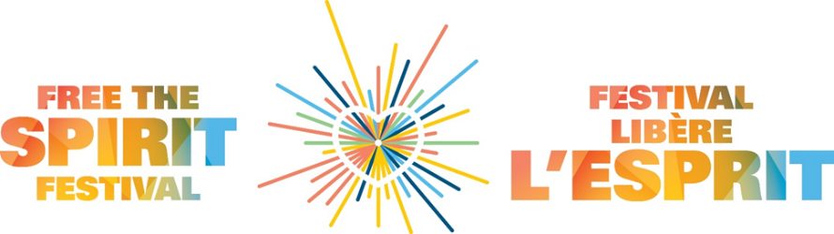

Call for Vendors
Annual Free the Spirit Festival
Maker’s Market
Saturday, September 19, 2026
stamant.ca/festival

The Free the Spirit Festival is more than a festival! It’s an opportunity to support and celebrate the diversity within our community at this inclusive outdoor event in support of St.Amant Foundation. Everyone is invited to attend (for FREE)! The Festival, attended by over 700 people, starts with a 2k walk and a 5K run for all to enjoy! We will have many other activities going on, such as food, inflatables, music, and more for everyone to enjoy!

We are looking for approximately 20 vendors to take part at this years’ Maker’s Market.

Date: Saturday, September 19, 2026, 10am-2pm
Location: St.Amant Parking Lot – 440 River Road
Entry Fees: $30 for a 10 x 10 space
$40 for a 10 x 10 space, 1 table and 2 chairs

Sales: The Maker’s Market is a sale of unique, handmade items. All vendors considered for the event will be subject to a jury process. If you are selected you will be sent an agreement that must be signed and returned to St.Amant.
Promotion: The event will be promoted through St.Amant social media accounts and we would expect vendors to help us extend our reach through their own social media pages. Social media presence will be considered an asset in the selection of our vendors.
Space: Each vendor will receive a 10 x 10 space. (Depending on the fee paid you can make arrangements to have a table and 2 chairs). All vendors must maintain and staff their booths for the full hours of the sale. Please note that you must provide your own tent (with tent weights), table cloth and signage. All vendors must be set up by 10:00 am.
Deadline for submission is September 4, 2026 successful applicants will be contacted the following week.
For more information: Nadine | nhink@stamant.ca or Celeste | cprescott@stamant.ca
If you are interested in donating one of your items, we are always looking for prizes to be used as incentives to encourage fundraising.

Application Form – Farmers’ and Artisans’ Market
Name:__________________________________________________________________________________
Business name:__________________________________________________________________________
Address:_________________________________________________________________________________
City:______________________ Province:________________ Postal Code:_________________________
Telephone:_________________________________________
Email:______________________________________________
Website address: _________________________________________________________________________
Please indicate the type of space you will require:
☐ $30 for 10x10 space only ☐ $40 for 10x10 space, 1 table and 2 chairs
Please indicate if you have a business page on the following social media outlets:
Facebook Twitter Instagram
Please provide a description of the items that you sell: ______________________________________________________________________________________________________________________________________________________________________________________________________________________________________________________________________________
What is the price range of the items you sell: _________________________________________________
How did you hear about the Free the Spirit Festival Market?
____________________________________________________________________________________________________________________________________________________________________________________
Where have you previously shown or sold your work? ____________________________________________________________________________________________________________________________________________________________________________________
Please send 1-3 photos to nhink@stamant.ca, if you are a successful applicant, you will be sent a contract and information relating to set up and tear down, and the exact location of your vendor table. Please note that past vendors are not guaranteed a space.
Signature: ___________________________________ Date:________________________________
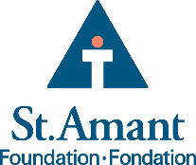
Submission deadline: September 4, 2026
Form can be emailed to Nadine Hink at nhink@stamant.ca or
mailed to: St.Amant Foundation, 440 River Rd., Winnipeg, MB, R2M 3Z9

